CHAPTER 1
INTRODUCTION
Community development plays a crucial role in achieving inclusive and sustainable national growth. Rural and semi-urban regions, which constitute a significant portion of India’s population, often face challenges related to skill gaps, limited educational exposure, inadequate infrastructure, and lack of awareness about sustainable practices. Addressing these challenges requires coordinated efforts involving educational institutions, local communities, and policy-driven initiatives.
Technical institutions and students have a vital responsibility in bridging the gap between knowledge and real-world societal needs. Through structured outreach programs, technical students can apply their academic learning to solve grassroots problems, thereby contributing to rural upliftment while simultaneously enhancing their professional and social competencies. The All India Council for Technical Education (AICTE) promotes such engagement by encouraging students to participate in rural development and social outreach activities.
The AICTE activities undertaken in this program were designed to address multiple dimensions of community development, including skill enhancement, environmental sustainability, educational empowerment, and economic growth. These activities focused on skilling the rural population, creating awareness regarding rainwater harvesting in both urban and rural areas, supporting local schools to improve academic outcomes and enrolment in higher and vocational education, and preparing an actionable business proposal aimed at enhancing village income.
The primary objectives of these AICTE activities were to empower rural communities with relevant skills, promote sustainable environmental practices, improve educational awareness and outcomes among school students, and contribute to economic self-reliance at the village level. Collectively, these initiatives aimed to foster holistic development while instilling social responsibility and leadership qualities among participating students.

CHAPTER 2
ACTIVITY-WISE DETAILS

2.1 SKILLING THE RURAL POPULATION

2.1.1 OVERVIEW
India’s rural population forms the backbone of the nation, yet many rural communities face limited access to quality education, vocational training, and employment opportunities. As India moves toward a knowledge- and service-driven economy, bridging the skill gap between urban and rural areas has become essential. The “Skilling the Rural Population” initiative was designed to empower rural individuals by providing practical, job-oriented skills that enhance employability, promote self-reliance, and support local economic development.
The initiative adopted a structured approach to identify local skill gaps and deliver training aligned with community potential and market demand. Training programs covered both traditional and modern skills, including agriculture-related practices, vocational trades, and digital literacy, while placing special emphasis on the inclusion of youth, women, and marginalized groups. Beyond economic benefits, the activity fostered confidence, dignity, and social empowerment among participants, reduced rural-to-urban migration, and contributed to building resilient and self-sustaining rural communities.
2.1.2 USE OF TECHNOLOGY
Technology has become a powerful enabler in rural skill development, just as digital payment platforms like PhonePe have simplified financial transactions for rural users. In the same way, smartphones and mobile applications are now being used to deliver skill training, improve digital literacy, and connect rural individuals to job and entrepreneurship opportunities.
- Digital Literacy Training: Rural people are taught how to use smartphones, apps like PhonePe, and digital services-essential skills for both employment and running small businesses.
- E-Certification and Job Matching Platforms: Technology helps candidates receive digital certificates and register on job platforms like NSDC, which work similarly to mobile-based interfaces like PhonePe.
- Awareness through Social Media and WhatsApp: Like PhonePe promotes its services online, awareness campaigns for skill development programs are also run using social media, WhatsApp, and local-language audio-visual content.
2.1.3 SUSTAINABLE DEVELOPMENT BEST PRACTICES
- Weekly digital literacy boot camps were conducted in local schools and community halls to improve basic digital skills.
- Visual and interactive learning methods, including regional-language videos and real-life simulations, were used to enhance understanding.
- Awareness sessions on cybersecurity were organized to educate participants about online fraud, safe digital transactions, and government applications.
- Inclusive training programs were conducted for women, self-help groups, and elderly participants to promote digital equity.
- WhatsApp and Telegram groups were used to share regular updates, tips, and follow-up support.
2.2 CREATING AN AWARENESS REGARDING RAIN WATER HARVESTING IN URBAN AND RURAL AREA

2.2.1 OVERVIEW
Water scarcity has emerged as a serious challenge in many parts of India due to rapid urbanization, deforestation, and excessive groundwater exploitation. Rainwater harvesting (RWH) is a simple and effective water conservation technique that involves collecting and storing rainwater for future use. Creating awareness about rainwater harvesting is essential to promote sustainable water management practices and reduce water stress in both urban and rural areas.
The awareness initiative focused on educating communities about the importance, benefits, and practical methods of rainwater harvesting. In urban areas, emphasis was placed on rooftop rainwater collection and water reuse for domestic purposes, while in rural regions, low-cost and traditional techniques such as percolation pits, farm ponds, and check dams were highlighted to support groundwater recharge and agriculture. Through community interactions, school programs, and demonstration models, the initiative encouraged public participation and responsible water usage, contributing to long-term water security and sustainable development.
2.2.2 USE OF TECHNOLOGY
- Interactive Mobile Campaigns: Awareness about rainwater harvesting is spread through mobile-based campaigns using WhatsApp, SMS, and voice messages in regional languages. These messages include simple, actionable tips and motivational success stories that even non-literate users can understand. Additionally, short video clips and animated infographics are shared on platforms like YouTube and Facebook to engage both rural and urban audiences in an easy and relatable format.
- IoT-Based Rainwater Monitoring Systems: In urban and institutional buildings, Internet of Things (IoT) devices are used to monitor water collection, storage levels, and usage patterns. These smart systems help in efficient management of harvested rainwater, reduce wastage, and provide real-time data that can be accessed via mobile apps. They also serve as live demonstration models that can be used to raise awareness in schools and residential societies.
- Community Radio & Interactive Voice Response (IVR) Systems: In areas with limited internet access, community radio stations and IVR systems play a key role. Pre-recorded messages, jingles, and expert interviews are broadcasted through local FM channels to educate listeners on the benefits and techniques of rainwater harvesting.
2.2.3 SUSTAINABLE DEVELOPMENT BEST PRACTICES
- Community participation was encouraged by involving local residents in planning, construction, and maintenance of rainwater harvesting structures, ensuring long-term ownership and sustainability.
- Eco-friendly practices were adopted by using locally available materials and avoiding cement linings to enhance natural groundwater recharge.
- Demonstration models and visual aids were established in public spaces to improve understanding of rainwater harvesting systems and their benefits.
- Urban–rural synergy was promoted through rooftop rainwater harvesting awareness in urban areas and digital outreach connecting urban and rural communities.
- Simple monitoring methods were used to track water levels and assess the long-term impact of rainwater harvesting initiatives.
2.3 HELPING LOCAL SCHOOLS TO ACHIEVE GOOD RESULT AND ENHANCE THEIR ENROLMENT IN HIGHER/ TECHNICAL/ VOCATIONAL EDUCATION
2.3.1 OVERVIEW
Education is a cornerstone of rural development, and supporting local schools in achieving better academic outcomes is essential for shaping the future of young learners. Strong academic performance enhances student confidence, builds parental trust, and strengthens institutional credibility, thereby encouraging enrolment in higher, technical, and vocational education. However, many local schools face challenges such as limited infrastructure, shortage of trained teachers, and inadequate awareness of diverse career pathways. Addressing these issues requires the adoption of modern teaching methods, integration of digital tools, academic mentoring for students, and career guidance initiatives that expose learners to opportunities beyond traditional education.
Beyond academic improvement, a holistic approach to education is necessary to promote inclusive and sustainable development. Encouraging extracurricular activities, leadership skills, and values-based learning helps prepare students to become responsible and skilled citizens. Collaboration with government agencies, non-governmental organizations, and industry partners provides additional resources, mentorship, and real-world exposure. By improving school performance and promoting enrolment in technical and vocational streams, rural communities can develop a skilled workforce that supports local entrepreneurship, reduces migration, and contributes to long-term socio-economic growth.
    - USE OF TECHNOLOGY
- Digital classrooms, e-learning platforms, and online educational resources were introduced to enhance teaching effectiveness and student engagement.
- E-commerce platforms, digital payments, and mobile banking were promoted to support village income generation and financial inclusion.
- Automation technologies such as smart irrigation systems, solar-powered machinery, and crop monitoring tools were highlighted to improve productivity and resource efficiency.
- Digital record-keeping systems and community information kiosks were encouraged to streamline local administrative activities and improve access to government schemes.
    - SUSTAINABLE DEVELOPMENT BEST PRACTICES
- Environmental sustainability was promoted through the adoption of renewable energy solutions, water conservation techniques such as rainwater harvesting, and village-level waste management practices.
- Social sustainability was ensured by encouraging inclusive education, community participation in decision-making, and skill development programs for youth and women.
- Economic sustainability was supported by strengthening local entrepreneurship, introducing value addition in agriculture and handicrafts, and promoting fair and sustainable income-generation practices.
- Technological sustainability was achieved through the use of automation, digital literacy initiatives, and community information systems to improve efficiency and transparency.
- Governance and policy alignment were maintained by integrating village development initiatives with national objectives and sustainable development goals, supported by partnerships and continuous monitoring.

PREPARING AN ACTIONABLE BUSINESS PROPOSAL FOR ENHANCING VILLAGE INCOME
2.3.1 OVERVIEW
Enhancing village income through an actionable business proposal requires a holistic approach that integrates local resources, community participation, and modern practices. Rural economies often rely heavily on agriculture, handicrafts, and small enterprises, yet face challenges such as limited market access, low productivity, and lack of financial inclusion. A well-designed proposal should focus on diversifying income sources by introducing value-addition in agriculture, promoting small-scale processing units, and encouraging entrepreneurship among youth and women. Leveraging technology—such as e-commerce platforms, mobile banking, and smart farming tools—can connect villagers to wider markets and improve efficiency.
Cooperative models and self-help groups can strengthen collective bargaining power, while skill development and vocational training programs prepare the workforce for both local enterprises and external opportunities. Sustainability must remain central, with practices like renewable energy adoption, waste management, and eco-friendly tourism ensuring long-term growth without harming the environment. By combining education, technology, and community-driven initiatives, the proposal aims to create a resilient rural economy where families enjoy improved livelihoods, reduced migration pressures, and greater social equity. Ultimately, this framework positions villages not as dependent units but as self-reliant hubs of innovation, productivity, and sustainable development.
    - USE OF TECHNOLOGY
- Smart agricultural technologies such as sensor-based irrigation, crop monitoring tools, and mobile advisory applications were promoted to enhance productivity and reduce resource wastage.
- Digital platforms, e-commerce systems, and automated processing units were encouraged to strengthen local enterprises, support value addition, and improve village income generation.
- Automation of village activities was supported through solar-powered machinery, IoT-enabled water management, and smart waste management systems to improve efficiency and sustainability.
- Digital and vocational skill development initiatives, including online training and virtual career guidance, were emphasized to enhance employability among rural youth and women.
- Community services and governance were strengthened through telemedicine, e-governance kiosks, and secure digital systems to improve transparency, accessibility, and service delivery
    - SUSTAINABLE DEVELOPMENT BEST PRACTICES
- Sustainable development practices promote long-term economic stability by creating self-reliant communities with diversified income sources, reducing vulnerability to economic and environmental risks.
- Cost efficiency is achieved through renewable energy adoption, resource conservation, and waste recycling, leading to reduced operational expenses.
- Eco-friendly and certified sustainable products provide market advantages by attracting premium pricing and increasing trust in regional, national, and international markets.
- Climate-resilient farming, water management, and disaster preparedness enhance the ability of rural communities to withstand environmental challenges.
- Inclusive and equitable practices empower women, youth, and marginalized groups while aligning village development initiatives with national policies and Sustainable Development Goals (SDGs).
  - AUTOMATION OF LOCAL ACTIVITIES.
2.5.1 OVERVIEW
Automation of local activities is a powerful driver of rural transformation, enabling communities to improve efficiency, reduce manual effort, and increase productivity across everyday tasks. In villages, many processes such as agriculture, water distribution, food processing, record-keeping, and small business operations are still carried out manually, which often leads to wasted time, higher costs, and limited scalability. By introducing affordable and context-appropriate automation—such as solar-powered pumps, smart irrigation systems, automated grain mills, and digital billing for shops—villagers can save resources while achieving higher output. Automation also strengthens transparency and accountability, for example through biometric attendance in schools or digital record-keeping in cooperatives.
Beyond agriculture and commerce, automated waste management, IoT-enabled water quality monitoring, and community information kiosks can modernize essential services, ensuring healthier and more sustainable living conditions. Importantly, automation does not replace human effort but complements it, freeing villagers to focus on higher-value activities such as entrepreneurship, skill development, and innovation. When integrated with education and training, automation becomes a tool for empowerment, preparing rural communities to participate in the digital economy while preserving cost-effectiveness and sustainability. In this way, automation of local activities acts as a bridge between traditional practices and modern development, positioning villages as self-reliant, future-ready hubs of growth.
2.5.2 USE OF TECHNOLOGY
- Smart agricultural automation, including sensor-based irrigation, solar-powered machinery, and automated processing units, was promoted to improve productivity and reduce resource dependency.
- Digital systems for local enterprises, such as automated billing, inventory management, e-commerce integration, and mobile payments, were encouraged to enhance efficiency and transparency.
- Community services were strengthened through automated water distribution, smart waste management, biometric attendance systems, and digital information kiosks.
- Governance and administrative efficiency were improved through digital record-keeping, secure transaction systems, monitoring dashboards, and cybersecurity measures.
2.5.3 SUSTAINABLE DEVELOPMENT BEST PRACTICES
- Environmental sustainability: Automation powered by renewable energy improves energy efficiency, conserves natural resources, and reduces pollution through smart monitoring and waste management.
- Social sustainability: Automated systems save time, enhance digital skills, and ensure inclusive participation of women and marginalized groups in development activities.
- Economic sustainability: Increased productivity, reduced post-harvest losses, and lower operational costs strengthen village income and market competitiveness.
- Technological advancement: Data-driven decision-making, transparent digital records, and scalable systems improve efficiency and accountability.
- Governance and policy alignment: Automation supports Sustainable Development Goals (SDGs), enables access to government support schemes, and enhances resilience to climate and disaster risks.

CHAPTER 3
INNOVATIVE APPROACHES
  - INNOVATIVE APPROACHES
- INNOVATIVE APPROACHES OF TO SKILL RURAL POPULATION
- Gamified Learning Modules: Mobile apps and games in local languages were developed to teach digital transaction steps and safety tips interactively.
- Voice-Assisted AI Chatbots: WhatsApp-based or IVR-enabled chatbots provided step-by-step guidance on using UPI and digital wallets in native languages.
- Digital Literacy on Wheels: A mobile van with laptops and internet connectivity traveled to villages, offering hands-on demonstrations of digital transactions.
- “Each One Teach One” Model: Digitally literate youth and students mentored elderly or untrained community members on using transaction apps.
- Digital Transaction Simulation Booths: Mock booths with dummy currency and interfaces allowed villagers to practice UPI and card payments safely.
- INNOVATIVE APPROACHES OF CREATING AN AWARENESS REGARDING RAIN WATER HARVESTING IN URBAN AND RURAL AREA.
- Pond Adoption Program (“My Pond, My Pride”): Local schools and families adopted specific ponds, taking responsibility for maintenance, cleanliness, and awareness campaigns.
- Rain Gauge DIY Kits: Low-cost, do-it-yourself rain gauge kits were distributed to schools and households for real-time rainfall monitoring.
- Gamification of Water Conservation: A mobile/web leaderboard was launched where schools and panchayats earned points for implementing rainwater harvesting and water-saving practices.
- Drone-Based Water Mapping: Drones and open-source GIS tools were used to identify high runoff areas and potential pond locations in urban and rural regions.
- Storytelling and Folk Theater (“Jal Kahani”): Street plays, puppet shows, and folk songs were used to spread awareness about rainwater harvesting in an engaging and culturally relevant manner.
- INNOVATIVE APPROACHES OF HELPING LOCAL SCHOOLS TO ACHIEVE GOOD RESULT AND ENHANCE THEIR ENROLMENT IN HIGHER/ TECHNICAL/ VOCATIONAL EDUCATION.
- Digital and Interactive Learning: Digital classrooms, smart boards, virtual labs, and gamified learning modules were introduced to make lessons engaging and improve conceptual understanding.
- AI-Based Personalized Support: Learning analytics and peer-to-peer mentoring were used to identify weak areas and provide customized remedial support for students.
- Teacher Development Programs: Continuous professional training, collaborative teaching practices, and digital teaching tools were provided to enhance instructional quality.
- Student Guidance and Motivation: Career counselling, industry visits, skill fairs, mentorship programs, and scholarships encouraged students to pursue higher, technical, and vocational education.
- Community and Technology Integration: Parents, local leaders, and NGOs were involved in school development, supported by digital libraries, internet connectivity, and performance tracking systems for transparency and accountability.
- INNOVATIVE APPROACHES OF PREPARING AN ACTIONABLE BUSINESS PROPOSAL FOR ENHANCING THE VILLAGE INCOME.
- Sustainable and Resource-Efficient Practices: Smart irrigation, renewable energy, and eco-friendly production methods reduce costs, improve resilience to climate change, and enhance market appeal.
- Inclusive Community Participation: Innovative models actively involve women, youth, and marginalized groups, building skills, confidence, and local pride while reducing migration.
- Economic Diversification and Market Competitiveness: Villages generate income through multiple streams, including agriculture, crafts, tourism, and certified organic or fair-trade products.
- Technological Integration: IoT, data analytics, digital platforms, and blockchain are used for real-time decision-making, transparency, scalability, and connectivity to broader markets.
- Governance and Policy Alignment: Innovative proposals align with government schemes, attract partnerships and subsidies, and support Sustainable Development Goals for measurable village growth.
- INNOVATIVE APPROACHES OF AUTOMATION OF LOCAL ACTIVITIES.
- Smart Agriculture and Farming: Sensor-based irrigation, drones for crop monitoring, automated food processing units, and solar-powered machinery were implemented to improve productivity, sustainability, and local value addition.
- Digitization of Local Enterprises: Automated billing, inventory management, packaging, e-commerce integration, and mobile payment systems enhanced efficiency, transparency, and market access for local businesses.
- Community Services Automation: IoT-based water distribution, smart waste management, biometric attendance, and community information kiosks improved service delivery and equitable resource allocation.
- Governance and Administrative Automation: Digital record-keeping, blockchain systems, automated dashboards, and cybersecurity tools ensured transparency, accountability, and secure management of village resources.
  - RESEARCH DONE
- Consumer Intention to Adopt E-Wallets in Rural India: An Investigation by Extending the Technology Acceptance Model, Mohammed Rashid, Mushahid Ali Shamsi, Imran Anwar, Imran Saleem, Ali Thabit Yahya
This study examines the factors influencing the acceptance of e-wallets among Indian rural consumers. By extending the Technology Acceptance Model (TAM) to include Digital Financial Literacy (DFL) and Perceived Financial Risk (PFR), the research analyzes their effects on consumers' attitudes and intentions to adopt e-wallet services. An online survey with 720 respondents from Uttar Pradesh was conducted, and Structural Equation Modelling was used for analysis. Findings indicate that DFL positively influences Perceived Usefulness and Perceived Ease of Use, while PFR negatively impacts them. The study offers insights for enhancing digital financial inclusion in rural areas.
- Adoption of UPI (Unified Payments Interface) by Rural People: An Empirical Investigation
This empirical study investigates the adoption of UPI among rural populations. It identifies key factors such as awareness, trust, and perceived ease of use that influence the adoption rate. The research highlights the need for targeted educational programs to enhance digital payment adoption in rural areas.
- Sustainable Water Resources Through Harvesting Rainwater and the Effectiveness of a Low-Cost Water Treatment, Samia Richards, Lakshminarayana Rao, Stephanie Connelly, Anjali V Raj, et al.
This study evaluates a rooftop rainwater harvesting system installed in a rural Indian school as part of a decentralized wastewater treatment system. It assesses the system's effectiveness in reducing groundwater dependency and examines the quality of stored rainwater over time. The research also investigates a low-cost chlorination treatment to ensure the safety of harvested water. Findings suggest that regular chlorination maintains microbial quality within acceptable standards, making the system a viable solution for sustainable water management in rural settings.
- Impact of Rainwater Harvesting Structures on Water Table Behavior and Groundwater Recharge in Parasai-Sindh Watershed of Central India, Reena Kumari, Ramesh Singh, R.M. Singh, R.K. Tewari, S.K. Dhyani, Inder Dev, Babloo Sharma, A.K. Singh
The study analyzes the impact of rainwater harvesting structures on groundwater recharge in the Parasai-Sindh watershed. By constructing 10 cost-effective structures, the research observed a 69% increase in water column during monsoon seasons and a 71.8% rise in net groundwater recharge post-intervention. The findings demonstrate the efficacy of rainwater harvesting in enhancing water availability for irrigation and reducing fallow land in the region
3.3 KNOWLEDGE AND UNDERSTANDING GAINED
- TO SKILL RURAL POPULATION
- Effective Communication Strategies: Training delivered in local languages, using real-time demonstrations, visual aids, and community participation, significantly enhanced understanding and retention.
- Cybersecurity Awareness: Insights were gained into common digital scams such as phishing, fake UPI handles, and OTP frauds, emphasizing the importance of educating users on secure digital behavior.
- Behavioral Shifts: Gradual adoption of digital transactions was noted, especially among women and youth, who emerged as early adopters and potential trainers within their communities.
- Sustainable Training Models: Peer learning and “train-the-trainer” approaches proved effective, with local influencers such as SHGs, Anganwadi workers, and shopkeepers playing a key role in expanding outreach.
- CREATING AN AWARNESS REGARDING RAIN WATER HARVESTING IN URBAN AND RURAL AREA
- Water Scarcity and Community Impact: Observed severe groundwater depletion in urban and rural areas and recognized that lack of awareness and planning leads to ineffective water management.
- Localized Solutions are Most Effective: Learned that small, decentralized rainwater harvesting structures, such as ponds and rooftop systems, work best, and active community engagement improves design and maintenance outcomes.
- Cost-Effectiveness and Sustainability: Understood that low-cost harvesting methods like soak pits, check dams, and percolation tanks ensure long-term water security, with community ownership and monitoring being crucial.
- Educational and Visual Tools: Demonstrations, models, charts, and murals in schools and public spaces enhanced understanding and engagement, with students and youth acting as effective ambassadors.
- Interconnectedness of Nature and Livelihoods: Recognized the link between rainwater harvesting, agricultural productivity, and ecosystem restoration, noting benefits such as reduced drought impact, increased irrigation, and biodiversity support.
- HELPING LOCAL SCHOOLS TO ACHIEVE GOOD RESULT AND ENHANCE THEIR ENROLMENT IN HIGHER/ TECHNICAL/ VOCATIONAL EDUCATION
- Role of Technology in Education: Digital classrooms, e-learning platforms, and smart tools significantly enhanced student engagement and learning outcomes, bridging the rural–urban divide in access to quality resources.
- Teacher Empowerment: Continuous professional training, collaborative teaching, and mentorship improved instructional effectiveness and classroom performance.
- Student Motivation and Support: Career counselling, mentorship programs, industry exposure, scholarships, and financial aid motivated students to pursue higher, technical, and vocational education, while reducing dropout rates.
- Community and Stakeholder Involvement: Active engagement of parents, local leaders, NGOs, and industries strengthened accountability, resource mobilization, and support for higher education enrolment.
- Policy Alignment and Holistic Approach: Aligning school initiatives with national skill development and vocational policies ensured sustainable improvement, combining technology, teacher development, student support, and community involvement to drive rural educational and socio-economic progress.
- PREPARING AN ACTIONABLE BUSINESS PROPOSAL FOR ENHANCING THE VILLAGE INCOME
- Economic Diversification: Recognized that relying solely on agriculture is insufficient; diversification into allied activities such as dairy, handicrafts, eco-tourism, and small enterprises, along with local processing for value addition, stabilizes income and reduces dependency on middlemen.
- Role of Technology: Digital platforms and e-commerce provide direct market access, while automation in farming, billing, and resource management enhances efficiency. Cybersecurity and digital literacy are essential for safe technology adoption.
- Community Participation: Collective models like cooperatives, SHGs, and FPOs strengthen bargaining power, and inclusive participation of women, youth, and marginalized groups ensures equitable distribution of benefits.
- Sustainability Practices: Renewable energy, waste recycling, and climate-resilient strategies reduce costs, protect resources, and safeguard livelihoods against environmental shocks.
- Policy and Social Impact: Aligning proposals with national rural development schemes and SDGs facilitates funding and support, while improved income empowers youth and women, reduces migration, and enhances overall quality of life.

- AUTOMATION OF LOCAL ACTIVITIES.
- Efficiency and Productivity: Automation in farming, commerce, and community services reduced manual effort, improved reliability, and increased productivity through smart irrigation, automated billing, and food processing units.
- Resource Management: IoT-enabled monitoring systems and automated dashboards provided real-time data on water, energy, and agricultural resources, ensuring optimal utilization and improved planning.
- Transparency and Governance: Digital record-keeping, blockchain systems, biometric attendance, and automated reporting enhanced trust, accountability, and fair distribution of benefits.
- Social and Economic Impact: Automation freed villagers from repetitive tasks, enabling focus on education, entrepreneurship, and skill development. Digital tools and automated systems improved profitability, reduced post-harvest losses, and strengthened local enterprises.
- Sustainability and Technological Advancement: Solar-powered machinery, eco-friendly automation, waste recycling, and exposure to IoT, AI monitoring, and digital payment systems promoted sustainable practices and technological literacy, while cybersecurity ensured safe adoption.
3.4 PROFESSIONAL VALUES AND BEST PRACTICES INCORPORATED
The initiatives actively fostered empathy, social responsibility, ethical conduct, and teamwork through direct engagement with rural and urban communities. Working with diverse groups promoted inclusiveness and cultural sensitivity, ensuring that interventions were respectful and accessible across varying literacy levels and age groups. Digital literacy efforts emphasized responsible usage, data privacy, and online security, while environmental awareness initiatives encouraged sustainability, community welfare, and ecological responsibility.
Collaboration with grassroots stakeholders—including school educators, village leaders, and women’s self-help groups—ensured community-driven, culturally contextualized implementation. Participants developed time management, project planning, and adaptability skills by addressing real-world challenges and modifying strategies based on feedback. Equity and inclusivity were central to all initiatives, ensuring participation of women, youth, and marginalized groups. Integrity and transparency were maintained through fair teaching practices, financial planning, and digital record keeping. Sustainability was embedded via renewable energy, eco-friendly practices, and climate-resilient strategies. Collaboration across parents, teachers, cooperatives, NGOs, industries, and government agencies strengthened long-term partnerships. Innovative yet practical technologies, such as smart classrooms, IoT systems, e-commerce platforms, and blockchain tools, were integrated in a manner that ensured affordability and ease of use. Collectively, these professional values and best practices ensured that the initiatives were ethical, inclusive, future-ready, and capable of delivering measurable impact in education, income generation, and local automation.
3.5 AREAS FOR FURTHER DEVELOPMENT
- TO SKILL RURAL POPULATION ON ONLINE TRANSACTION AWARENESS:
- Develop structured, age-specific digital training modules using interactive content in regional languages.
- Establish local “Digital Mitra” volunteers or help centers for continued support post-training.
- Strengthen collaboration with banks, post offices, and government bodies to build trust and ensure secure adoption.
- Introduce periodic refresher sessions to reinforce digital safety practices and platform updates.
- Incorporate audio-visual content and app simulators to make learning more intuitive for low-literacy participants.
- FOR RAINWATER HARVESTING AWARENESS AND IMPLEMENTATION:
- Integrate smart technologies like IoT-based water level monitoring for real-time data collection.
- Conduct skill-building workshops for local youth to manage and maintain water harvesting structures.
- Encourage school-based environmental clubs to promote long-term ecological awareness.
- Link community efforts with government schemes for funding, technical expertise, and scalability.
- Promote collaboration with environmental experts, NGOs, and civic authorities to support large-scale water conservation planning.
- HELPING LOCAL SCHOOLS TO ACHIEVE GOOD RESULT AND ENHANCE THEIR ENROLMENT IN HIGHER/ TECHNICAL/ VOCATIONAL EDUCATION
- Digital Infrastructure Expansion: Establish additional smart classrooms, computer labs, and reliable internet connectivity. Provide access to e-libraries and digital learning platforms to broaden student exposure.
- Teacher Training & Capacity Building: Implement continuous professional development programs focused on modern pedagogy and digital tools. Develop subject-specific training modules for technical and vocational education streams.
- Career Guidance & Counselling: Set up structured career counselling cells in schools to guide students toward higher education and vocational pathways. Organize industry exposure visits, mentorship programs, and skill fairs.
- Financial Support Mechanisms: Expand scholarships, stipends, and financial aid for economically weaker students. Collaborate with industries and NGOs to sponsor vocational training opportunities.
- Policy Integration & Monitoring: Align school initiatives with national skill development and vocational education policies. Implement automated dashboards and data analytics to track student performance, enrolment trends, and dropout rates, and design targeted interventions accordingly.
- PREPARING AN ACTIONABLE BUSINESS PROPOSAL FOR ENHANCING THE VILLAGE INCOME.
- Economic Diversification: Introduce new income streams beyond agriculture, such as allied activities, micro-enterprises, handicrafts, and eco-tourism, to ensure stable and resilient livelihoods.
- Infrastructure & Technology Enhancement: Expand storage, processing, and digital infrastructure. Integrate smart irrigation, solar-powered machinery, automated billing systems, and IoT-enabled monitoring to improve productivity and efficiency.
- Skill Development & Education: Provide targeted vocational training, digital literacy workshops, and entrepreneurship programs to equip villagers with practical skills for sustainable income generation.
- Sustainability & Resource Management: Promote renewable energy adoption, waste recycling, and eco-friendly practices to reduce costs, conserve resources, and increase long-term viability.
- Community Participation & Governance: Strengthen collective models such as cooperatives, self-help groups, and farmer associations. Ensure transparent record-keeping, inclusive participation, and engagement with local stakeholders to support accountability and equitable benefits.
- AUTOMATION OF LOCAL ACTIVITIES.
- Infrastructure Expansion: Strengthen electricity and internet connectivity, and expand solar-powered units to support automated systems sustainably.
- Capacity Building & Training: Provide hands-on training and digital literacy programs for villagers to operate and maintain automated tools effectively.
- Technology Customization: Adapt automation solutions to local needs and design user-friendly interfaces in local languages.
- Financial Accessibility: Promote microfinance schemes, subsidies, and partnerships to make automation affordable for small farmers and entrepreneurs.
- Sustainability & Eco-Friendly Practices: Encourage renewable energy, automated waste recycling, and climate-resilient systems to reduce environmental impact.
3.6 CHALLENGES AND SOLUTIONS
- TO SKILL RURAL POPULATION ON ONLINE TRANSACTION AWARENESS:
CHALLENGES | SOLUTIONS
Limited access to smartphones or poor internet connectivity | Conducted offline, device-sharing sessions and used printed materials for hands-on learning
Fear of fraud and mistrust in digital payments | Focused on cybersecurity education and live demos to build trust and familiarity
Low literacy levels among some community members | Used audio-visual aids, regional language instructions, and icon-based app navigation methods
Hesitancy to adopt new technologies, especially among the elderly | Provided one-on-one mentoring and peer support using local youth volunteers
Lack of continuity post-training | Proposed the formation of local digital support groups (“Digital Mitras”) for ongoing guidance

- RAINWATER HARVESTING AWARENESS AND IMPLEMENTATION
CHALLENGES | SOLUTIONS
Lack of awareness about the importance of rainwater harvesting | Conducted awareness drives using street plays, posters, and interactive village sessions
Difficulty in identifying suitable locations for harvesting structures | Collaborated with local authorities and used manual terrain surveys for site selection
Limited funds and resources for digging ponds or building structures | Mobilized community labor and linked the initiative with government schemes like MGNREGA
Maintenance and upkeep of structures over time | Encouraged community ownership and appointed local maintenance volunteers
Resistance due to traditional practicesorlackof immediate benefits | Shared real-life success stories and involved local influencers to advocate for participation

- HELPING LOCAL SCHOOLS TO ACHIEVE GOOD RESULT AND ENHANCE THEIR ENROLMENT IN HIGHER/ TECHNICAL/ VOCATIONAL EDUCATION
CHALLENGES | SOLUTIONS
Limited Infrastructure | Invest in smart classrooms, computer labs, and reliable internet; leverage government schemes and NGO support.
Teacher Training Gaps | Provide continuous professional development, workshops, and mentorship programs to enhance teaching quality.
Low Student Motivation & Career Awareness | Establish career counselling cells, mentorship programs, and industry exposure visits to guide students toward higher and vocational education.
Financial Constraints | Expand scholarships, stipends, and financial aid; encourage NGO or CSR support for vocational training.
Lack of Community Engagement | Strengthen parent-teacher associations and involve local stakeholders in school development initiatives.

- PREPARING AN ACTIONABLE BUSINESS PROPOSAL FOR ENHANCING THE VILLAGE INCOME.
CHALLENGES | SOLUTIONS
Over dependence on Agriculture | Diversify into allied activities like dairy, handicrafts, food processing, and eco-tourism.
Limited Market Access | Introduce e-commerce platforms, cooperatives, and direct market linkages to buyers.
Lack of Infrastructure | Establish community cold storage, small processing units, and automated packaging systems.
Financial Constraints | Provide microfinance, subsidies, and partnerships with NGOs/government schemes.
Skill Gaps | Launch skill development programs, vocational training, and entrepreneurship workshops.

- AUTOMATION OF LOCAL ACTIVITIES
CHALLENGES | SOLUTIONS
Limited Infrastructure | Expand solar-powered systems, improve connectivity, and set up shared community automation hubs.
Low Digital Literacy | Provide training programs, workshops, and user-friendly interfaces in local languages.
High Initial Costs | Offer subsidies, microfinance schemes, and public-private partnerships to make automation affordable.
Resistance to Change | Conduct awareness campaigns, pilot projects, and demonstrate tangible benefits of automation.
Data Security Risks | Implement cybersecurity measures, train local administrators, and use secure platforms.

3.7 FEEDBACK AND CONTINUOUS IMPROVEMENT
Participant input and continuous improvement have been central to the success of initiatives such as digital literacy and online transaction awareness, rainwater harvesting programs, school development, village income enhancement, and automation of local activities. Many participants, especially the elderly and digitally inexperienced, highlighted the need for slower-paced, hands-on tutorials, which led to the introduction of step-by-step guides, demonstration videos in regional languages, small-group mentoring, and simulation-based practice sessions.
In the rainwater harvesting drive, community input emphasized greater involvement in maintenance and technical understanding, prompting the organization of training sessions, distribution of educational materials, and the development of low-cost monitoring tools. Similarly, schools utilized feedback from teachers, students, parents, and local stakeholders to identify gaps in teaching practices, infrastructure, and career guidance, enabling the implementation of targeted interventions that enhance learning outcomes and enrolment in higher, technical, and vocational education.
Village income initiatives benefited from continuous monitoring of financial results, stakeholder participation, and market trends, guiding adjustments in income diversification, technology adoption, and sustainable practices. For automation projects, community reviews ensured that systems remained user-friendly, cost-effective, and secure, while iterative improvements addressed challenges related to digital literacy, infrastructure, and cybersecurity. By embedding structured feedback mechanisms such as surveys, community meetings, and automated dashboards, these initiatives remain dynamic, responsive, and future-ready, ensuring long-term sustainability and maximized impact across educational, economic, and social domains.
CHAPTER 4
SNAPSHOTS
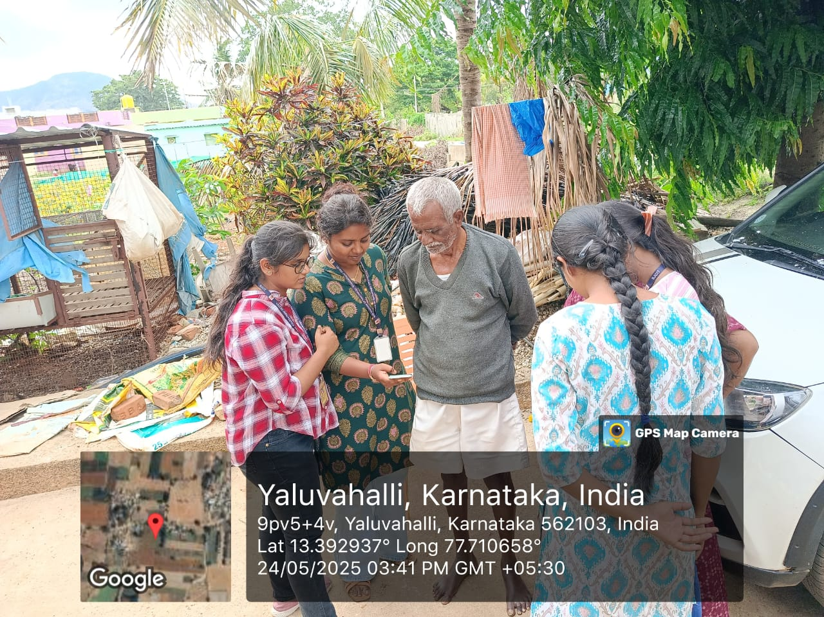
Fig 1: Demonstrating the use of PhonePe app to a local resident.
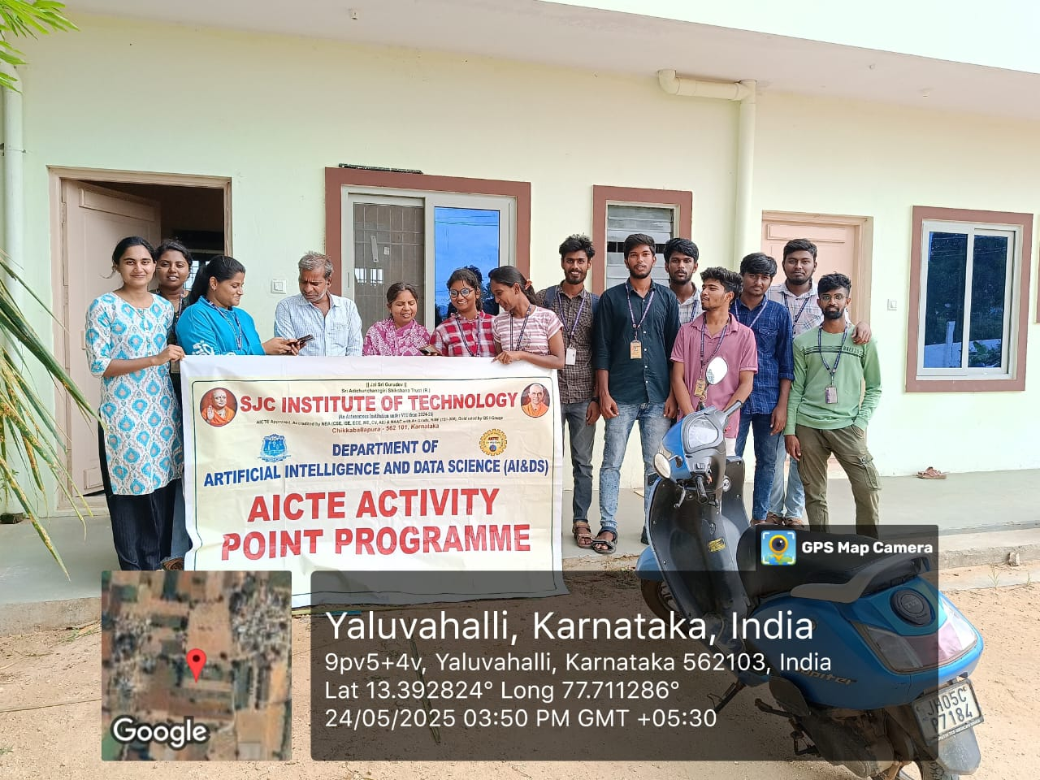
Fig 2: Group Demonstration of PhonePe app usage.

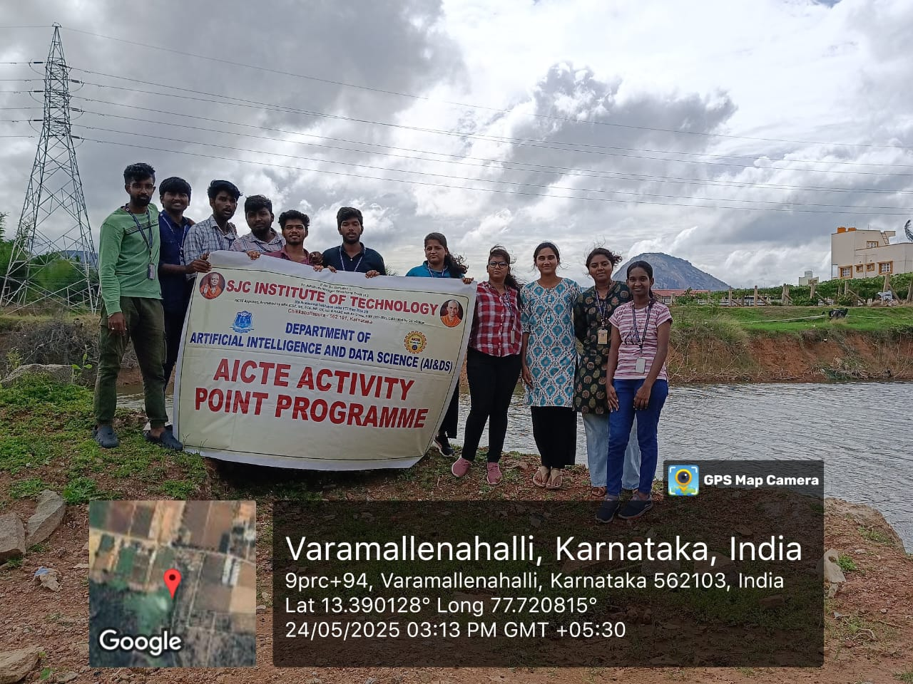
Fig 3:Group Demonstration of Awarness regarding Rain water harvesting
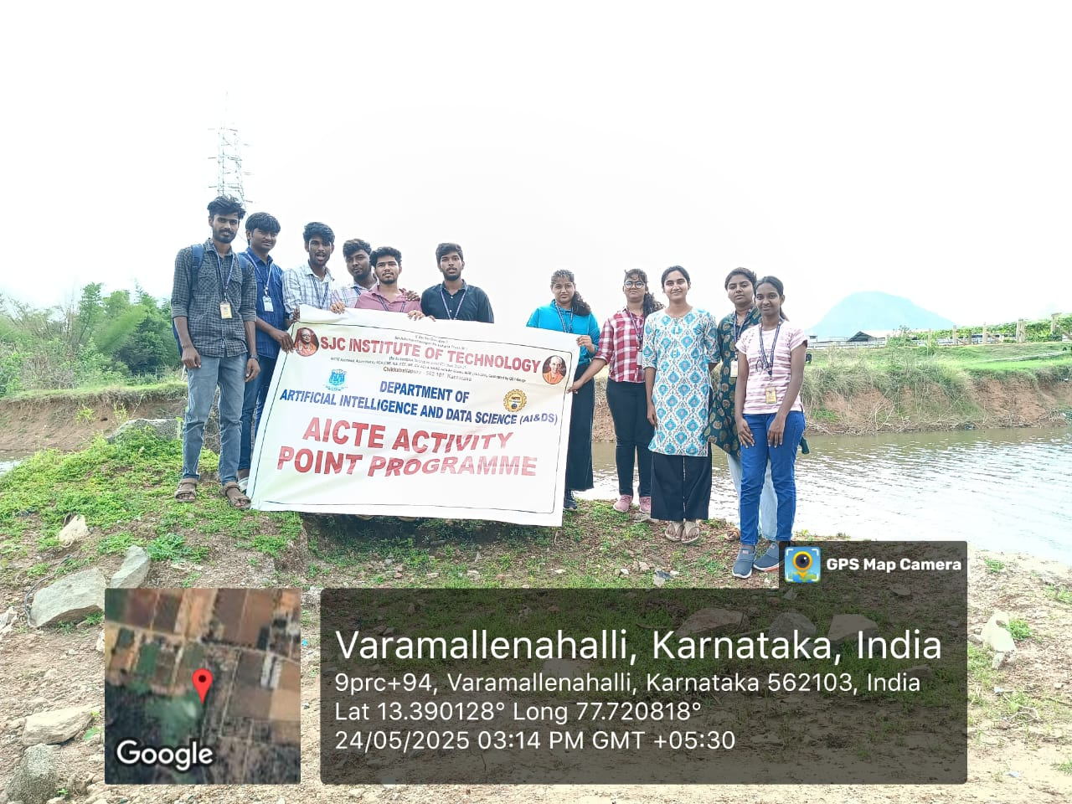
Fig 4: Group Demonstration of Awarness regarding Rain water harvesting

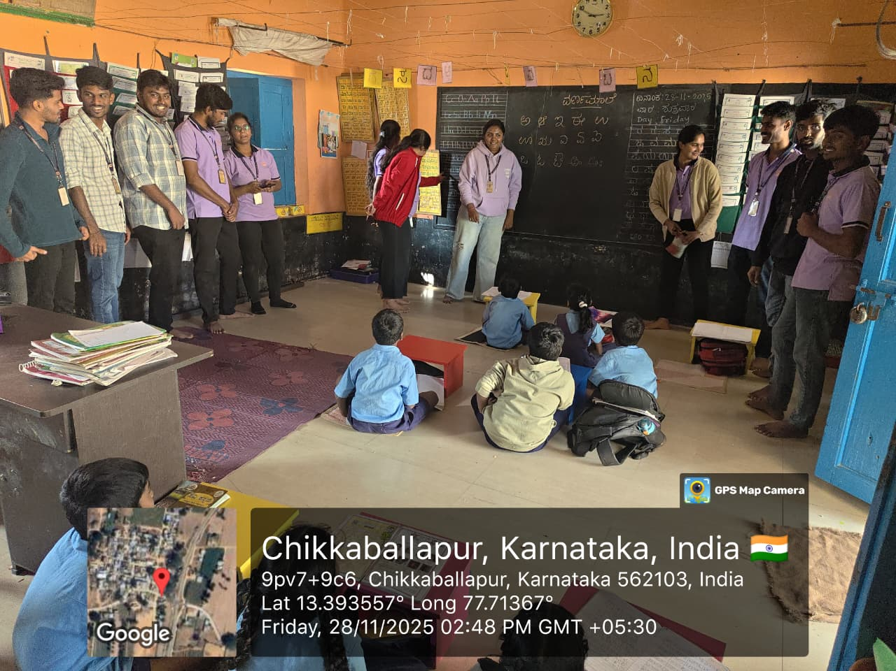
Fig 5: Student Engagement and Interactive Learning Session at a Rural School
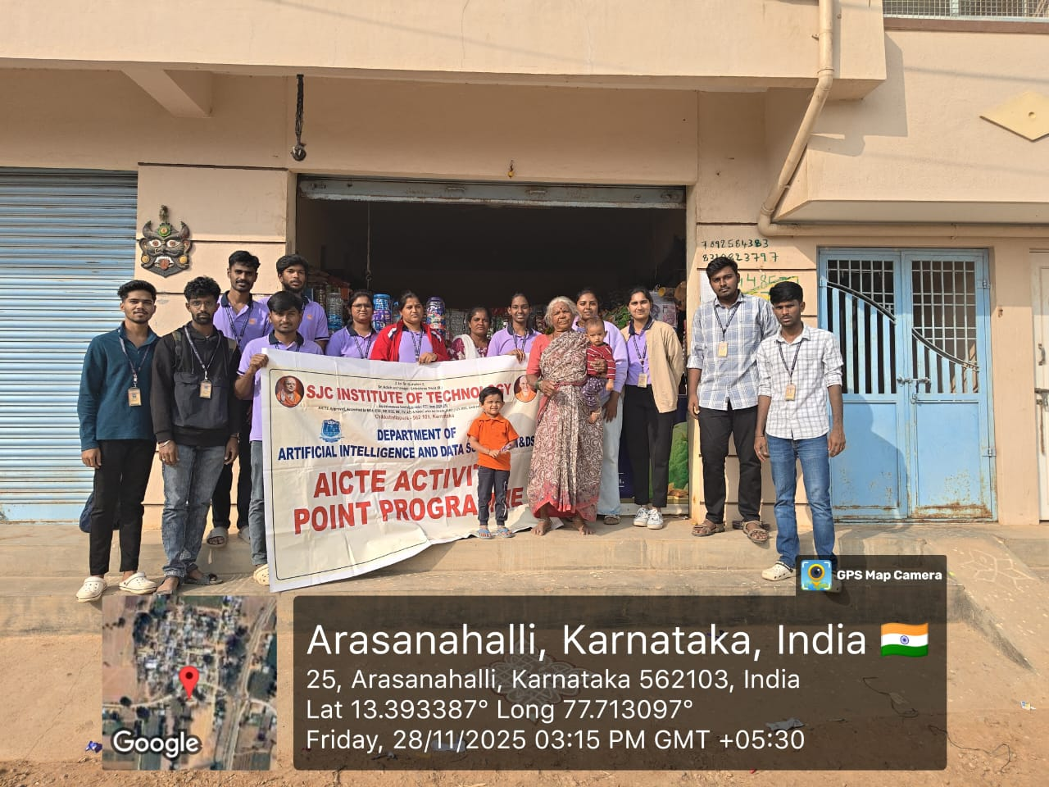
Fig 6: Community Engagement and Awareness Program

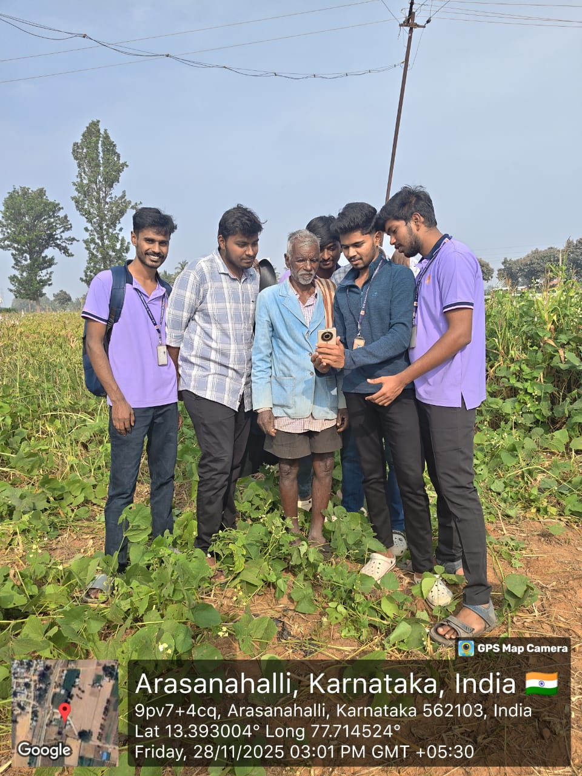
Fig 7: Field Interaction with Farmers for Digital Awareness and Technology Demonstration
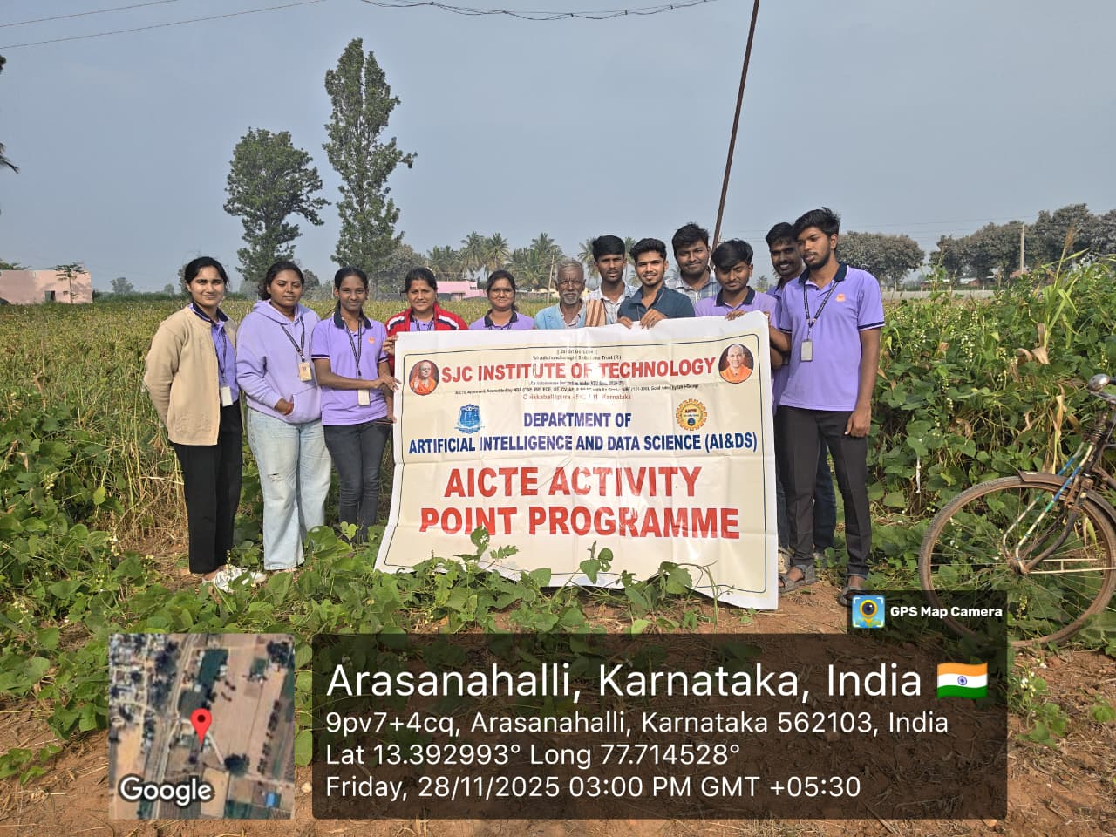
Fig 8: Community Outreach and Awareness Programme

CHAPTER 5
CONCLUSION
A holistic approach to community development was achieved by integrating education, digital empowerment, sustainability, economic enhancement, and automation. Each activity addressed specific local challenges while reinforcing the outcomes of the others, resulting in inclusive and sustainable development aligned with long-term societal and national goals.
Strengthening local schools contributed to improved academic performance, increased awareness of higher, technical, and vocational education pathways, and better career orientation among students. Focused guidance and supportive learning environments helped build a strong educational foundation, equipping students with the skills and confidence required for future academic and professional success.
Digital literacy and online transaction awareness initiatives enhanced technological confidence within rural communities. Practical exposure to digital tools enabled safe participation in online financial systems, promoted financial inclusion, and reduced dependence on intermediaries. Inclusive training approaches ensured accessibility across age groups, fostering self-reliance in digital adoption.
Village income enhancement efforts emphasized actionable business proposals focusing on income diversification, agriculture-allied activities, skill development, and eco-friendly enterprises. These initiatives strengthened economic resilience, reduced migration, and improved household stability while ensuring transparency, financial inclusion, and community participation.
Automation of local activities improved efficiency, transparency, and productivity by reducing manual effort and enhancing accuracy in service delivery and monitoring. Digital systems enabled communities to focus on higher-value activities such as entrepreneurship and innovation, while secure platforms strengthened trust in technology adoption.
Together, these initiatives established a sustainable development framework where education nurtured skilled individuals, economic activities generated opportunities, digital inclusion ensured accessibility, and automation enhanced efficiency. The integrated outcomes position communities as resilient, self-reliant, and future-ready while preserving local identity and social cohesion.
REFERENCE
- Rashid, M., Shamsi, M. A., Anwar, I., Saleem, I., & Yahya, A. T. (2025). Consumer intention to adopt e-wallets in rural India: An investigation by extending the technology acceptance model. Cogent Business & Management, 12(1). https://doi.org/10.1080/23311975.2024.2428776
- Ministry of Electronics & Information Technology (MeitY). (2022). Digital India Programme Annual Report. Retrieved from https://www.meity.gov.in
- Reserve Bank of India. (2023). Financial Inclusion Index. https://rbi.org.in/Scripts/PublicationVisionDocuments.aspx
- National Bank for Agriculture and Rural Development (NABARD). (2021). All India Rural Financial Inclusion Survey (NAFIS). https://www.nabard.org
- IITM Journal of Business Studies. (2023). Adoption of UPI by Rural People: An Empirical Investigation. https://journalsiitmjp.com/index.php/iitmjbs/article/view
- Richards, S., Rao, L., Connelly, S., Raj, A. V., et al. (2021). Sustainable water resources through harvesting rainwater and the effectiveness of a low-cost water treatment. Journal of Environmental Management, 286, 112223. https://doi.org/10.1016/j.jenvman.2021.112223
- Kumari, R., Singh, R., Singh, R. M., et al. (2014). Impact of rainwater harvesting structures on water table behavior and groundwater recharge in Parasai-Sindh watershed of Central India. Indian Journal of Agroforestry, 16(2). https://epubs.icar.org.in/ejournal/index.php/IJA/article/view/103436
- Ministry of Jal Shakti. (2022). Jal Shakti Abhiyan: Catch the Rain – Annual Report. https://jalshakti-dowr.gov.in
- The Energy and Resources Institute (TERI). (2023). Urban water crisis and the role of rainwater harvesting. Retrieved from https://www.teriin.org
- UNESCO. (2020). Water for Sustainable Living in India: Rainwater harvesting as a key strategy. Retrieved from https://unesdoc.unesco.org

